## Result Lab 2

Name: Le Thi Kim Anh

ID: DE180827

1. Navbar



1. Carousel



1. Movies List

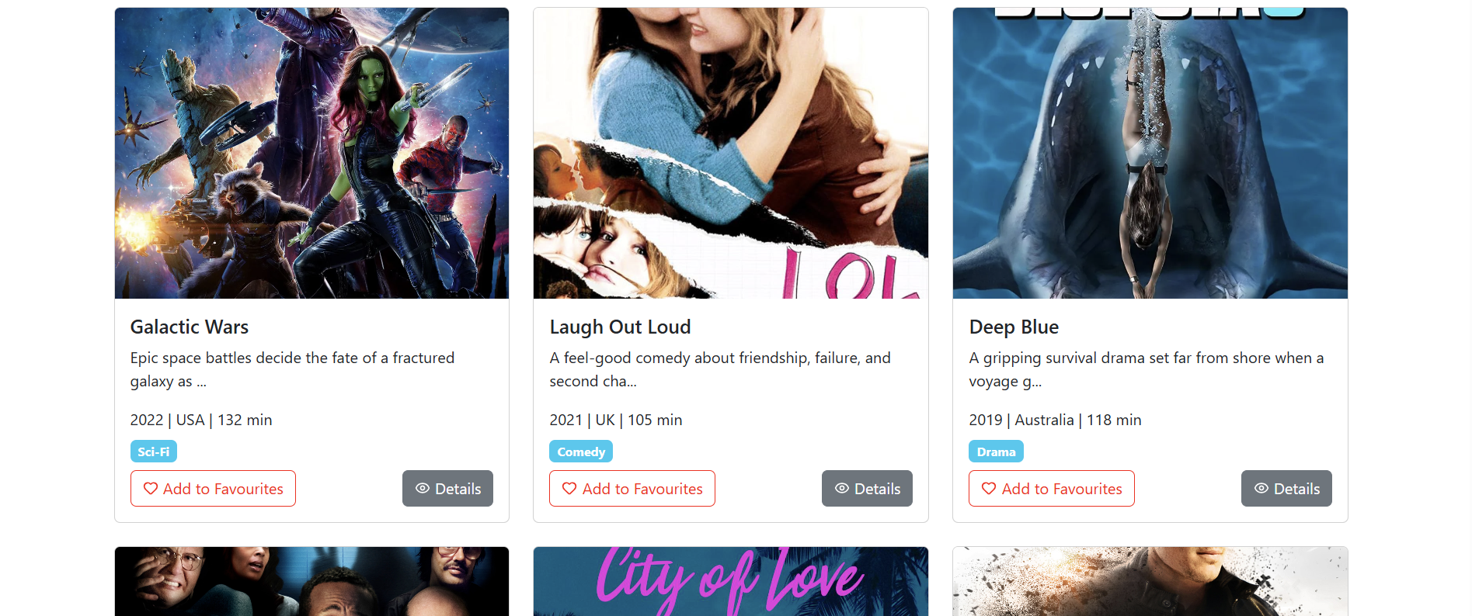

1. Filter

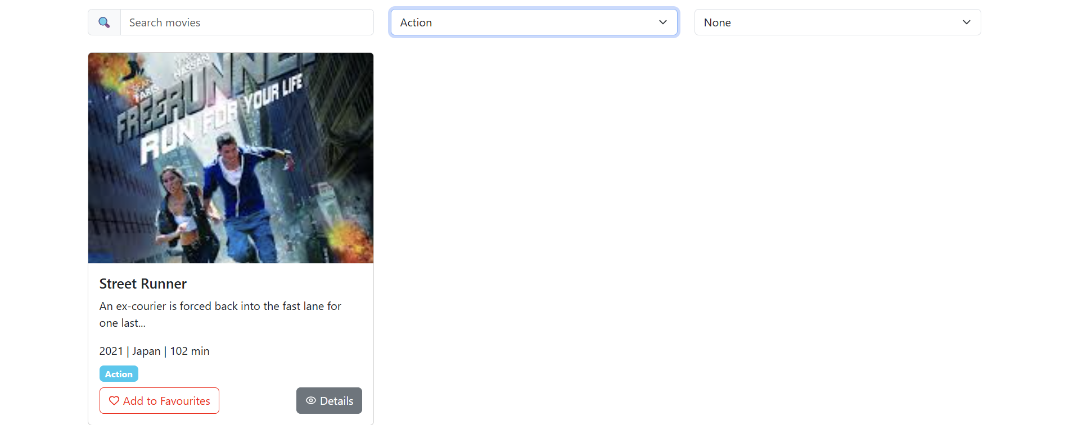

1. Search Movie

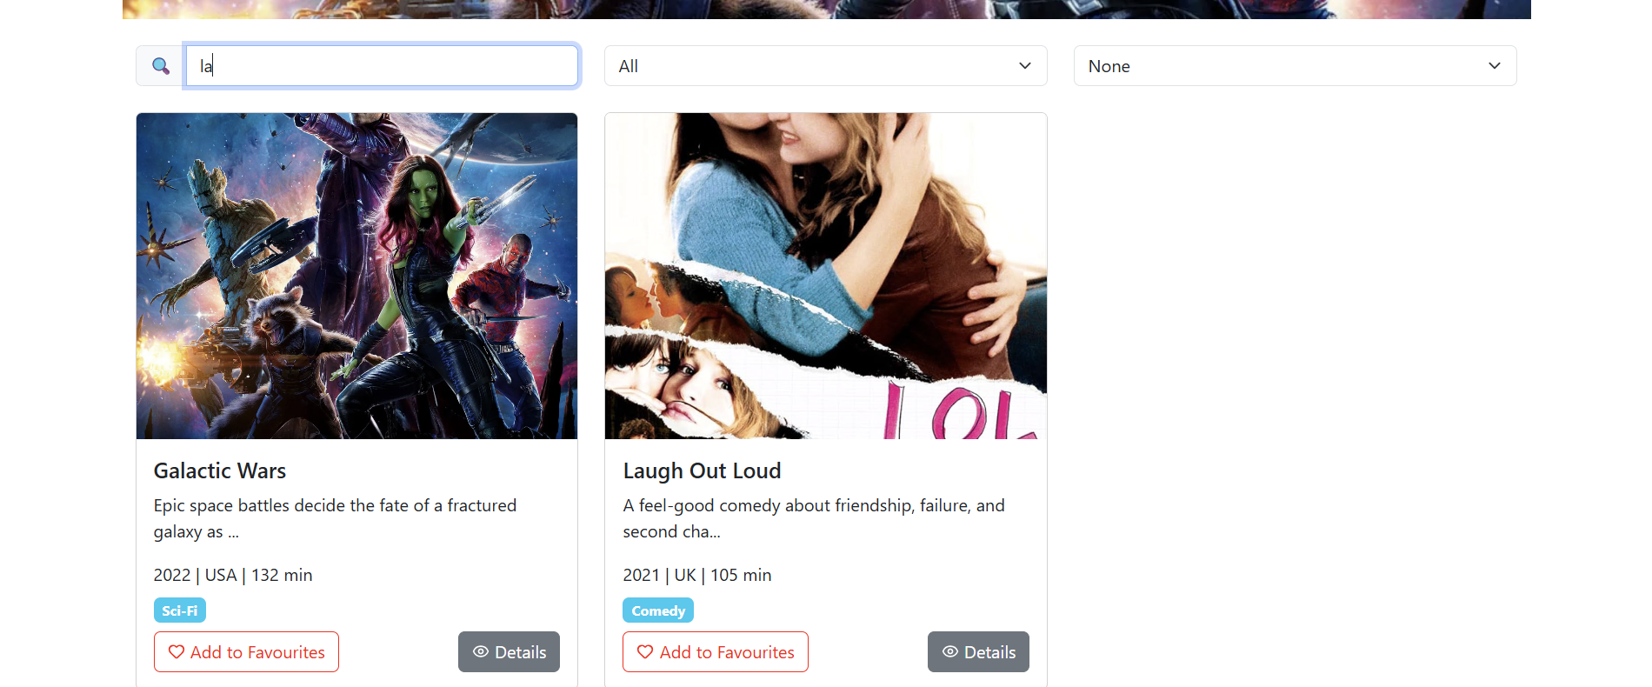

1. Sort Movie

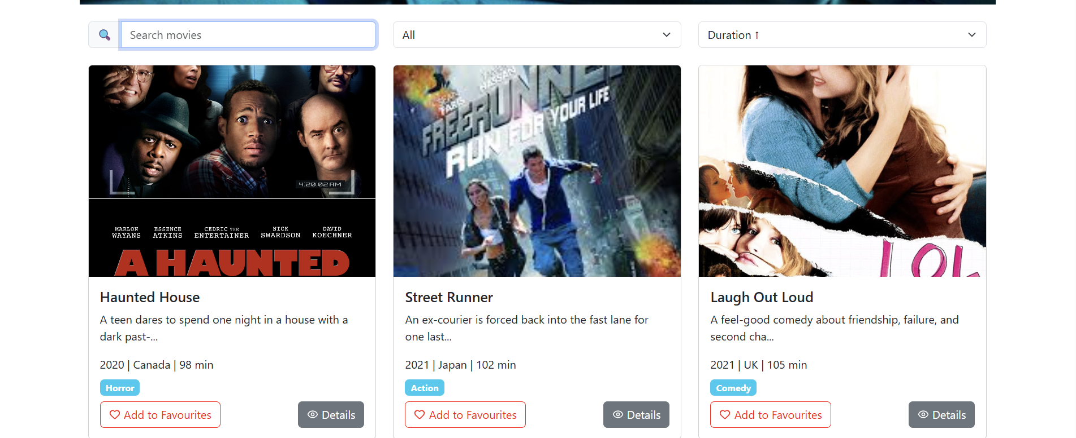

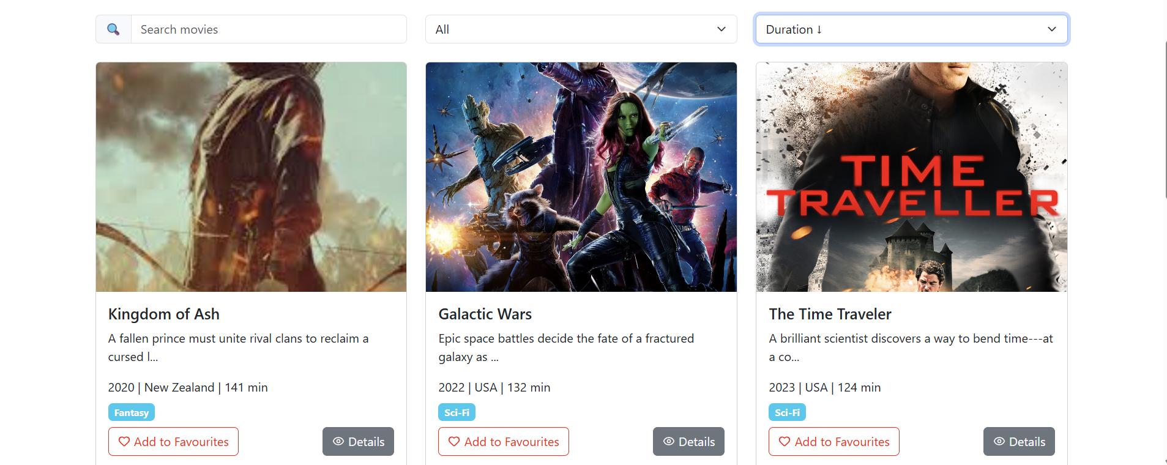

1. Favourites & Toast



1. Movie Request Form + PropTypes

